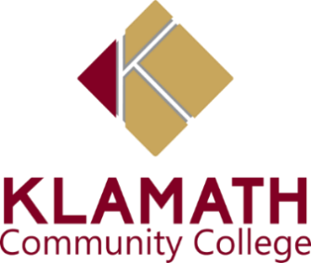

Weekly ASKCC Meeting
October 6, 2022
9:15AM

Minutes

- Roll Call
Present: Deveyn Horne, Jennifer Stone, Chantal Ramirez, Jaden Pantoja-Roberts, Carissa Catterall, Kassandra Hedrick, Erica
Absent:

- Agenda & Minutes
Approve 9/30 Agenda
Review and Adopt Agenda for 9/30, 2022
Motion to Approve Agenda by jennifer
Second by Chantal Ramirez

- Hispanic Heritage
- Kassandra asked to set a budget and mentioned she order the sweet bread out of her budget.Kassandra stated they were expecting 250 people.
- Kassandra reached out to monarch and they will be doing tamales, and Oscars mom will be making a thickened hot chocolate. We will have candy bags.
- Jennifer motioned $800 for the budget, Chantal Second the motioned
- Deveyn asked if we were going to have any resources and Kassandra stated they did not reply back

- First Gen week
  - Kassandra mentioned that there is suppose to be a dinner for first gen week. Zach would like to do the dinner Wednesday after hours and would to do something Tuesday and Thursday
  - Erica asked what first gen week is and Kassandra explained that it is for first generation college students
  - Kassandra stated that we will be coordinating the dinner and come up for events for Tuesday and Thursday. Pam is looking into beanie for first gen students
  - Deveyn mentioned doing trivia and giving out small prizes
  - Kassandra asked if Jennifer and Chantal could speak at the event

- Harvest Festival
  - Carissa was able to contact someone about the pumpkins

- Actions Items

- Open Discussion

- Adjourn
- Jennifer motioned to adjourn the meeting, Chantal Second the motion.
- Meeting was adjourned at 10:00 a.m

